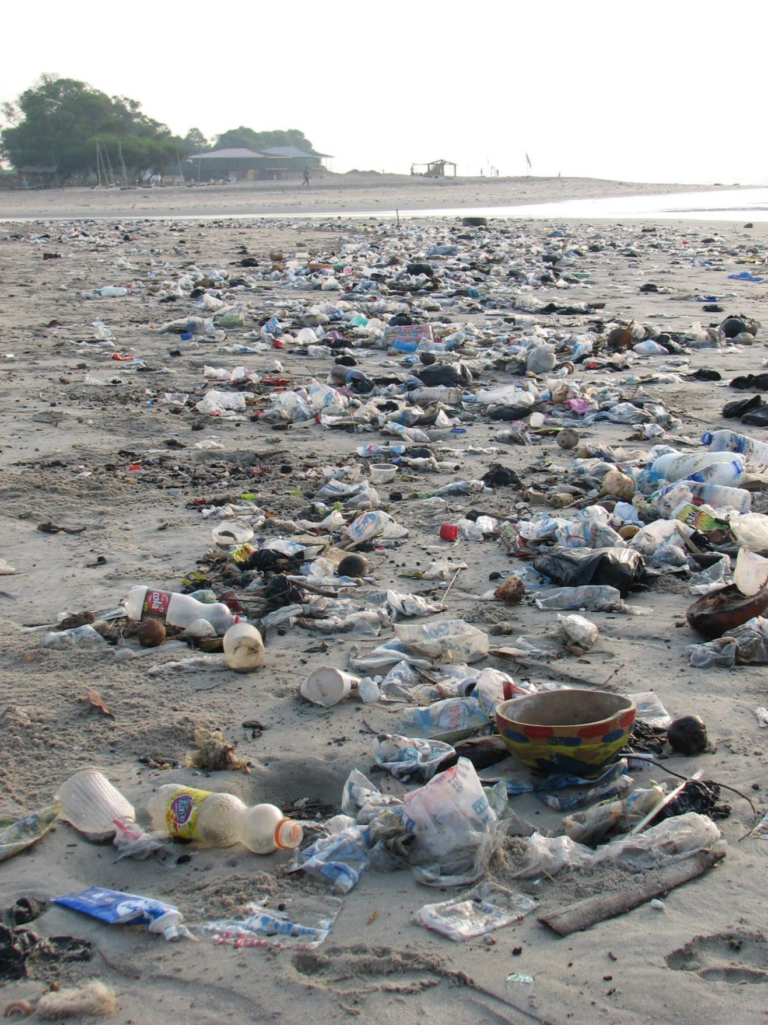
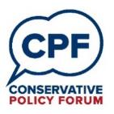

Conservative Conservation

“The Conservatives always have to clean up Labour’s mess…”

Dear Colleagues,
Paper 2/2018: Conservative Conservation
“The clue’s in the name: Conservatives are – and always have been – the world’s best conservationists.” (James Delingpole)
This CPF discussion paper continues our series of papers that encourage members to reflect on policies of particular concern to voters under 40, with whom last year’s general election showed we have a distinctive challenge. Once again, discussions will be more greatly informed if groups are able to include younger members. If your CPF Group does not usually include many members aged under 40, then we would encourage you to use this opportunity to reach out to younger voters in your constituency.
Please advertise the CPF paper on your Facebook and Twitter pages and encourage participation of non-members as well. It would be great if you could post a photo online of your meeting too. Let people know that you are interested in them and want to understand their perspective.
We want to ensure that as many associations and as many members are able to engage in this vital and wide-ranging discussion. The closing date for this brief is therefore 31 May, after the elections that many areas will be contesting.
Please send your responses to the paper, via CPF.Papers@conservatives.com, using the associated response form published on the CPF website.
A summary of responses to this paper will be sent to the Secretary of State for the Environment, the Rt Hon Michael Gove MP; CPF Chairman, George Freeman MP; Conservative Vice-Chairman for Policy, Chris Skidmore MP; and the Prime Minister’s Policy Unit within a month of the closing date for submissions.
The next paper will be on health and social care and will be published at the start of June. Thank you. We look forward to hearing your ideas on this important topic.
The CPF Team
www.conservativepolicyforum.com
@ConservativePF

One Page Summary
“Respecting nature’s intrinsic value and making sure we are wise stewards of our natural world is critical if we are to leave the environment in a better state than we inherited it. Our Environment Plan sets out how over the next 25 years we will radically reduce the waste that is choking oceans and rivers, cleanse our air of toxic pollutants and create new habitats for our most precious wildlife to thrive.” (The Rt Hon Michael Gove MP, Secretary of State for the Environment, Food & Rural Affairs)
Introduction: The Challenge
Without action the world faces the progressive loss of the natural capital on which all growth—natural, human and economic—ultimately depends.
Questions for discussion
- Climate change: How might we better cultivate the resources, policies and people that will allow us to mitigate and adapt to change?
- Renewable energy generation: How might we transition more quickly away from an over-dependency on non-renewable fossil fuels?
- Air quality: What policies should we enact to reduce harmful pollutants?
- Plastics: What policies should we enact to reduce the amount of plastic waste and increase recycling?
- Trees: How can we encourage more tree planting?
- Farming and fishing: What should farming and fishing policies look like outside of the European Union?
- Brexit: How might we use the opportunity that leaving the EU provides to strengthen and enhance our environmental protections?
- Global leadership: How else might we further build on our global leadership and existing commitment to international development so as to create international coalitions to tackle particular environmental challenges? Or should we be focusing more on improving our own country’s environmental quality?
- In what ways should the Government harness market mechanisms and regulation—from auctions and subsidies, to taxes and bans—to support best practice and to encourage greater investment in environmentally-friendly goods and services?
- Who pays? How might your proposals be paid for?
“Conservative Governments have always taken our responsibility to the natural environment seriously.” (The Rt Hon Theresa May MP, Prime Minister)
“Labour has too often treated the environment in a way that suggests it’s come as an afterthought.” (Angela Eagle, Labour MP)
“As Conservatives, we are committed to leaving the environment in better condition than we inherited it.” (Conservative Manifesto)
Appendix: Facts and Figures

Introduction: The Challenge
“Respecting nature’s intrinsic value and making sure we are wise stewards of our natural world is critical if we are to leave the environment in a better state than we inherited it. Our Environment Plan sets out how over the next 25 years we will radically reduce the waste that is choking oceans and rivers, cleanse our air of toxic pollutants and create new habitats for our most precious wildlife to thrive.” (The Rt Hon Michael Gove MP, Secretary of State for the Environment, Food & Rural Affairs)
The world’s population is growing at an unprecedented rate, with a worldwide migration from rural areas to cities and a growth in the global middle class which is driving demand for more, and better quality, food, safe drinking water, comfortable housing, reliable energy and new consumer goods. The pressures placed on our global environment by this growth will be formidable—whether it’s greenhouse gas emissions in our atmosphere contributing to global warming, desertification and soil erosion reducing the space for cultivation, deforestation leading to the disappearance of valuable carbon sinks and precious habitats, air pollution from traditional industry and intensive agriculture adding to health costs, waste poisoning our oceans or iconic landscapes under threat from the need for further development.
Without action we face the progressive loss of the natural capital on which all growth—natural, human and economic—ultimately depends. So the imperative to husband, indeed wherever possible, enhance our natural capital—safeguarding our oceans, cleaning our rivers, keeping our soils fertile, protecting biodiversity—has to be at the heart of any plan for our country and our world.
That’s why, at the start of this year, the Conservative Government published A Green Future, our 25 year plan to improve the environment. This was described as a potential “game-changer” and welcomed by a coalition of 31 organisations, including the Campaign to Protect Rural England, Friends of the Earth, National Trust, RSPB and WWF UK. It outlines specific goals and targets for each of the following areas: clean air, clean and plentiful water, thriving plants and wildlife, reducing the risks of harm from environmental hazards, using resources from nature more sustainably and efficiently, enhancing beauty, heritage and engagement with the natural environment, mitigating and adapting to climate change, minimising waste, managing exposure to chemicals and enhancing biosecurity.
The UK is already a world-leader on climate change and other environmental issues. For instance, at the end of 2017 the Conservative Government launched the Powering Past Coal Alliance with Canada. We have been among the most successful countries in the developed world in growing our economy while simultaneously reducing emissions. The UK Blue Belt programme is at the forefront of marine protection, with UK experts partnering to deliver better scientific understanding of environments and ecosystems, making a significant contribution towards the UK’s commitment towards the UN Convention on Biological Diversity’s target to protect 10 per cent of the world’s coastal and marine areas by 2020. We have also used our influence and resources to help developing countries with their own “clean growth”.
The cost of many low-carbon technologies has fallen dramatically in recent years: renewable power sources like solar and wind are comparable in cost to coal and gas in many countries; energy efficient light bulbs are over 80 per cent cheaper today than in 2010; the cost of electric vehicle battery packs has tumbled by over 70 per cent in this time; and the cost of offshore wind is now half what it was just two years ago. As a result of such technological innovation, new high value jobs, industries and companies have been created. This, in turn, is driving a new, technologically innovative, high growth and high value low-carbon sector of the UK economy. Thanks to our world-leading expertise in these technologies and our global leadership in “green finance”, we are successfully exporting eco-friendly goods and services around the world.⁹
Our last paper highlighted how, among the under-40s, the top issues that young people believe should be discussed more often by politicians are health and climate change, followed by education and housing. Among 18-24-year-olds, climate change came top of the list, followed by education, health and housing.
According to a poll from last year, Conservatives believe that the three most important environmental issues for government to support are increasing renewable energy generation (52 per cent), improving air quality (30 per cent) and tackling climate change (29 per cent). The issue is also considered relatively important among those whose votes we will need to win at the next election if we are to secure a Conservative majority:
 | Con | Lab | LD | None
Proportion who say pollution/environment is the most important issue facing Britain today | 3% | 5% | 1% | 3%
Proportion who see pollution/environment as the main/other important issues facing Britain today | 7% | 11% | 24% | 8%
Questions for discussion
- Climate change: How might we better cultivate the resources, policies and people that will allow us to mitigate and adapt to change?
- Renewable energy generation: How might we transition more quickly away from an over-dependency on non-renewable fossil fuels?
- Air quality: What policies should we enact to reduce harmful pollutants?
- Plastics: What policies should we enact to reduce the amount of plastic waste and increase recycling?
- Trees: How can we encourage more tree planting?
- Farming and fishing: What should farming and fishing policies look like outside of the European Union?
- Brexit: How might we use the opportunity that leaving the EU provides to strengthen and enhance our environmental protections?
- Global leadership: How else might we further build on our global leadership and existing commitment to international development so as to create international coalitions to tackle particular environmental challenges? Or should we be focusing more on improving our own country’s environmental quality?
- In what ways should the Government harness market mechanisms and regulation—from auctions and subsidies, to taxes and bans—to support best practice and to encourage greater investment in environmentally-friendly goods and services?
- Who pays? How might your proposals be paid for?
The Conservative Track Record
“Conservative Governments have always taken our responsibility to the natural environment seriously:
- In the nineteenth century it was Benjamin Disraeli’s Conservative government which passed the River Pollution Prevention Act, providing the first legal environmental protections for our waterways;
- A Conservative government in the 1950s passed the Clean Air Act, making the Great Smog of London a thing of the past;
- Margaret Thatcher was the first world leader to recognise the threat of global warming and helped to protect our ozone layers through her work on the Montreal Protocol; and
- David Cameron restored environmentalism to a central place in the Conservative agenda.” (The Rt Hon Theresa May MP, Prime Minister)
We have already gone further than EU regulation requires of us to protect our environment:
- 7,886 square miles of coastal waters around the UK—roughly equivalent to the area of Wales, or 13 times the size of Greater London—are now Marine Conservation Zones.
- Banned the use of microbeads—tiny pieces of plastic—in cosmetic and personal care products to ensure our marine life is better protected.
- Introduced a 5p charge on plastic bags that resulted in 83 per cent fewer bags being distributed and millions donated to environmental, educational and other good causes.
- Nearly doubled maximum litter fines to £150 and ensured that individuals can be fined for litter thrown from their vehicles.
- Issued a call for evidence on how a deposit return scheme could work to reduce waste and to encourage greater recycling of plastic, metal and glass drinks containers.
- Introduced a new Clean Air Fund and total investment of £3.5 billion in improving air quality, including ending the sale of all new petrol and diesel cars and vans by 2040.
- Hosting an international Zero Emission Vehicle Summit in autumn 2018 to further the development of the low emission and electric car market.
- Working with countries around the world to phase out coal, including ending support, except in rare situations, for public financing of new coal-fired power plants overseas.⁶
- Providing £140 million to support poorer communities to cope with deforestation, natural disasters and climate extremes.²⁰
- Setting out plans for a new, world-leading independent statutory environmental body to hold government to account, ensuring that we continue to enhance standards.
- Imposed a ban on ivory sales to help bring an end to the poaching of elephants, putting the UK front and centre of global efforts to end the insidious trade in ivory.
- We convened the first ever Conference on the Illegal Wildlife Trade to help eradicate an abhorrent crime and to protect species better from the threat of extinction.
- Delivering our manifesto commitment for CCTV to be required in every slaughterhouse in England to ensure standards of treatment are upheld.
- Increasing the maximum sentence for the worst acts of animal cruelty in England and Wales ten-fold. We recognise that animals are sentient beings and we will enshrine that understanding in primary legislation.
- Making £40 million grants available to help livestock, dairy, arable and horticultural farmers improve farm productivity through investing in new technology.
- Launching the Woodland Carbon Fund and Woodland Creation grant to help land-owners plant more trees to protect wildlife, boost the timber sector and reduce flood risk.
- Supporting the release of beavers to the Forest of Dean, to help enhance biodiversity and reduce the risk of flooding.
- Supporting further restrictions on neonicotinoid pesticides in an attempt to protect our bee populations and other pollinators.
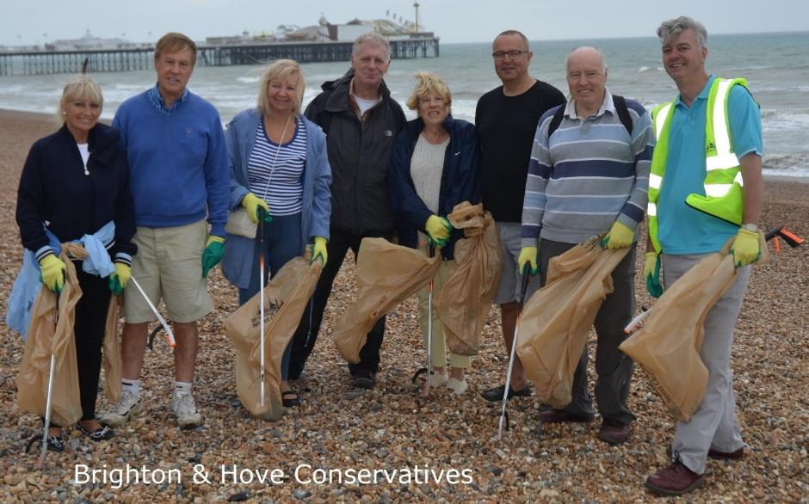
Labour’s Record of Failure
“Labour has too often treated the environment in a way that suggests it’s come as an afterthought.” (Angela Eagle, Shadow Treasury Minister, 2015)
“Our party saw the environment as just another discreet policy issue like housing, education or transport. We did not understand and ensure that environmental policies were integrated in every aspect of government decision-making.” (Barry Gardiner MP, 2010)
- Labour gave up £7 billion of Britain’s rebate in return for reforms to the Common Agricultural Policy which never materialised.
- Labour allowed the Common Fisheries Policy to spiral out of control, with no end in sight for the environmentally damaging process of requiring fishermen to throw back into the sea any fish caught that exceeded their quota for that particular type.
- Labour sold off 25,000 acres of forest with hardly any protections on public access: an area larger than cities such as Leicester, Coventry, Hull, and Nottingham.
- Labour failed to protect the Green Belt. Labour’s Regional Spatial Strategies imposed local housing quotas and Whitehall’s 2006 planning guidance weakened protections.
- Labour failed to protect critical infrastructure from flooding and other natural hazards. Labour’s approach was criticised by the Pitt Review into the 2007 floods as being “uncoordinated and reactive.”
- Labour oversaw a major decline in our dairy industry, with the number of dairy farms falling by 41 per cent between 1998 and 2008 - from 17,014 to 10,112.
- Labour’s failures led directly to the outbreak of foot and mouth disease in 2007, damaging the livestock industry and costing the taxpayer around £50 million.
- Labour ministers ignored advice from the Treasury’s tax policy section ahead of the 2000 Budget that diesel fumes were toxic and, relative to petrol, contained “higher emissions of the particulates and pollutants which damage local air quality.”
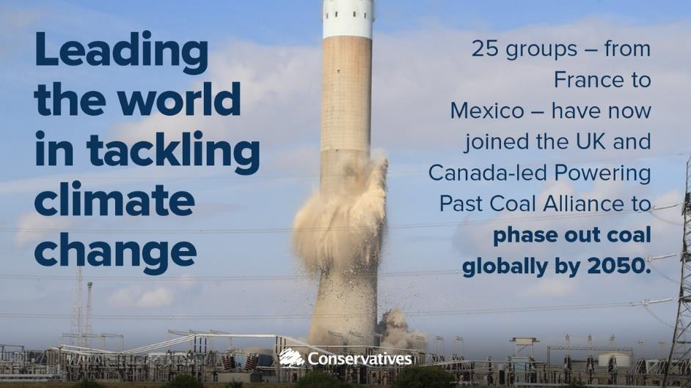
What Our Manifesto Said
Natural gas from shale: “We will set up a new Shale Environmental Regulator, which will assume the relevant functions of the Health and Safety Executive, the Environment Agency and the Department for Business, Energy and Industrial Strategy. This will provide clear governance and accountability, become a source of expertise, and allow decisions to be made fairly but swiftly.” (p.23)
Prosperous towns and cities across Britain: “Our towns and cities should be healthy, well-designed and well-tended places. We will take action against poor air quality in urban areas. In addition to the 11 million trees we are planting across our nation, we will ensure that 1 million more are planted in our towns and cities, and place new duties on councils to consult when they wish to cut down street trees. … We will do more to reduce litter, including by supporting comprehensive rubbish collection and recycling, supporting better packaging, taking new powers to force councils to remove roadside litter and prosecuting offenders.” (p.25)
Our countryside communities: “We have huge ambitions for our farming industry: we are determined to grow more, sell more and export more great British food. We want to provide stability to farmers as we leave the EU and set up new frameworks for supporting food production and stewardship of the countryside. So we will continue to commit the same cash total in funds for farm support until the end of the parliament. We will work with farmers, food producers and environmental experts across Britain and with the devolved administrations to devise a new agri-environment system, to be introduced in the following parliament.”
“Our countryside and rural communities have been moulded by generations of farmers. We will help Natural England to expand their provision of technical expertise to farmers to deliver environmental improvements on a landscape scale, from enriching soil fertility to planting hedgerows and building dry stone walls. We will deliver on our commitment to improve natural flood management, such as improving the quality of water courses to protect against soil erosion and damage to vulnerable habitats and communities. We will continue to ensure that public forests and woodland are kept in trust for the nation, and provide stronger protections for our ancient woodland.”
“We will continue to take action to improve animal welfare. We will implement our proposed reforms on pet sales and licensing and will make CCTV recording in slaughterhouses mandatory. As we leave the European Union, we can take early steps to control the export of live farm animals for slaughter.”
“Finally, we pledge to be the first generation to leave the environment in a better state than we inherited it. That is why we shall produce a comprehensive 25 Year Environment Plan that will chart how we will improve our environment as we leave the European Union and take control of our environmental legislation again.” (pp.25-26)
Our coastal communities: “When we leave the European Union and its Common Fisheries Policy, we will be fully responsible for the access and management of the waters where we have historically exercised sovereign control. A new Conservative government will work with the fishing industry and with our world-class marine scientists, as well as the devolved administrations, to introduce a new regime for commercial fishing that will preserve and increase fish stocks and help to ensure prosperity for a new generation of fishermen. To provide complete legal certainty to our neighbours and clarity during our negotiations with the European Union, we will withdraw from the London Fisheries Convention. We will continue our work to conserve the marine environment off the coast of the United Kingdom.” (p.27)
Protecting the global environment: “The United Kingdom will lead the world in environmental protection. As Conservatives, we are committed to leaving the environment in better condition than we inherited it. That is why we will continue to take a lead in global action against climate change, as the government demonstrated by ratifying the Paris Agreement. We were the first country to introduce a Climate Change Act, which Conservatives helped to frame, and we are halfway towards meeting our 2050 goal of reducing emissions by eighty per cent from 1990 levels. We will champion greater conservation co-operation within international bodies, protecting rare species, the polar regions and international waters. We will work with our Overseas Territory governments to create a Blue Belt of marine protection in their precious waters, establishing the largest marine sanctuaries anywhere in the world.” (p.40)
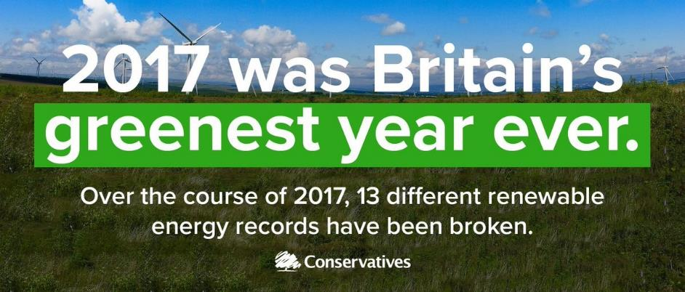

Appendix: Facts and Figures
The top three policy issues voters feel senior politicians do not discuss enough and want to see them discuss more, according to age¹⁰
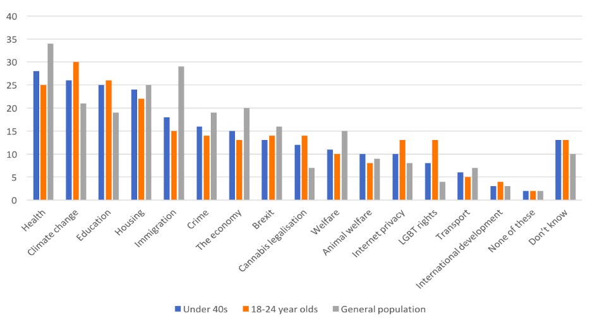
The three most important environmental issues for the Government to support, according to Conservatives ¹¹
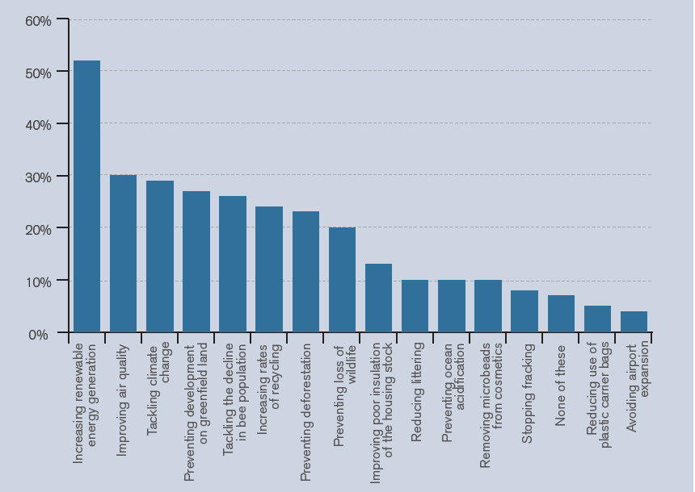
UK and G7 economic growth and emissions reductions⁹
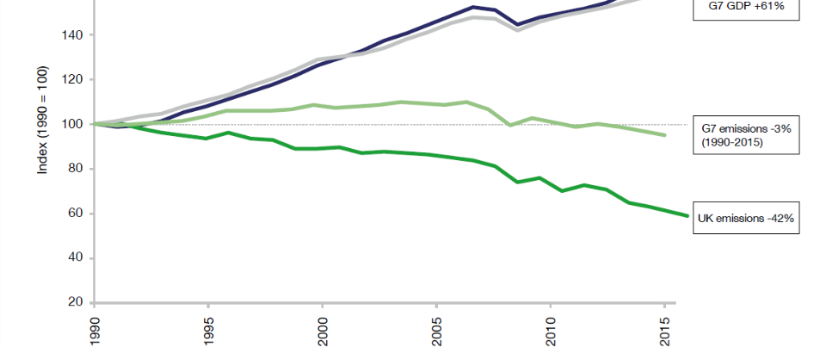
- Our carbon emissions have fallen while our national income has risen faster and further per person than any other nation in the G7. Since 1990, the UK cut emissions by 42 per cent, while our economy grew by 67 per cent. This is in no small part due to the 85 per cent reduction in coal use we’ve seen in that time.⁶
- The UK has used its influence and resources to help developing countries with their own “clean growth”. Our actions to date are expected to save almost 500 million tonnes of carbon dioxide over the lifetime of the projects, more than the entire annual emissions of France.⁹
The steps in our 25 Year Environment Plan
- We have pledged to eliminate all avoidable plastic waste by the end of 2042. We know that we must reduce the demand for plastic, reduce the number of plastics in circulation and improve our recycling rates and that is why we have taken this significant step. We will lead the way by removing all consumer single use plastic in central government offices.
- We will encourage supermarkets to introduce plastic-free aisles in which all the food is loose. This will give people the choice to make greener decisions and promote the use of less damaging plastic packaging.
- We will extend the 5p carrier bag charge to all retailers in England. As a direct consequence of introducing the charge, we used nine billion fewer plastic bags in the first 21 months of the scheme. This led to a reduction of 83 per cent and £95 million being donated to environmental educational, and other good causes.
- We have issued a call for evidence on a new charge or tax on single-use plastic items, such as takeaway containers. This will encourage industry to take greater responsibility for the environmental impacts of their products and make them easier to recycle.
- We will inject new funding into plastics innovation through a bid into the government’s £7 billion research and development pot.
- We will support a Northern Forest. It will be a new community woodland for Cheshire, Lancashire and Yorkshire, provide a new and enduring amenity for the growing population of the north of England, and act as a carbon sink for the UK.
- We will allow young people to learn more about the natural world, targeting schools in disadvantaged areas first. This will be supported by £10 million of investment.
- We will use the United Kingdom’s international influence to drive positive change around the world. When we host the Commonwealth Heads of Government Meeting in April we will put the sustainable development of our oceans on the agenda. We will direct our development spending to help developing nations reduce plastic waste, increase our own marine protected areas at home, and establish new Blue Belt protections in our Overseas Territories.
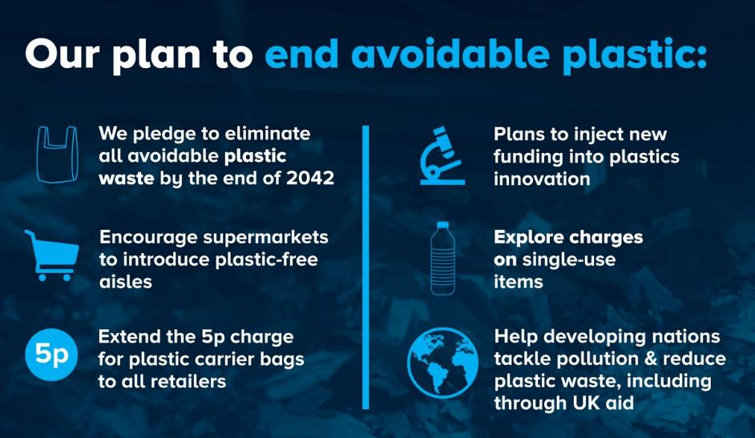
European Recycling League Table 2016
“The evidence from across Europe shows that deposit schemes work. However, it’s easy to recycle plastic bottles in mixed recycling, and the infrastructure is already in place to do this here. … Glass bottles is where the bigger problem lies in the UK and is particularly valuable because glass can be recycled over and over again. ... In Sweden this is already happening and if we don’t start a glass bottle scheme in the UK, we’re in danger of falling behind.” (Bruce Bratley, CEO, First Mile)
The UK ranks 13th in the European Union for municipal waste recycling: the UK’s combined recycling and composting rate stood at 43.5 per cent in 2015, compared with an average rate of 45.6 per cent across the EU in 2016. The top spot is held by Germany, which recycled 66.1 per cent of waste, with Austria ranked second, with a recycling rate of 57.6 per cent.
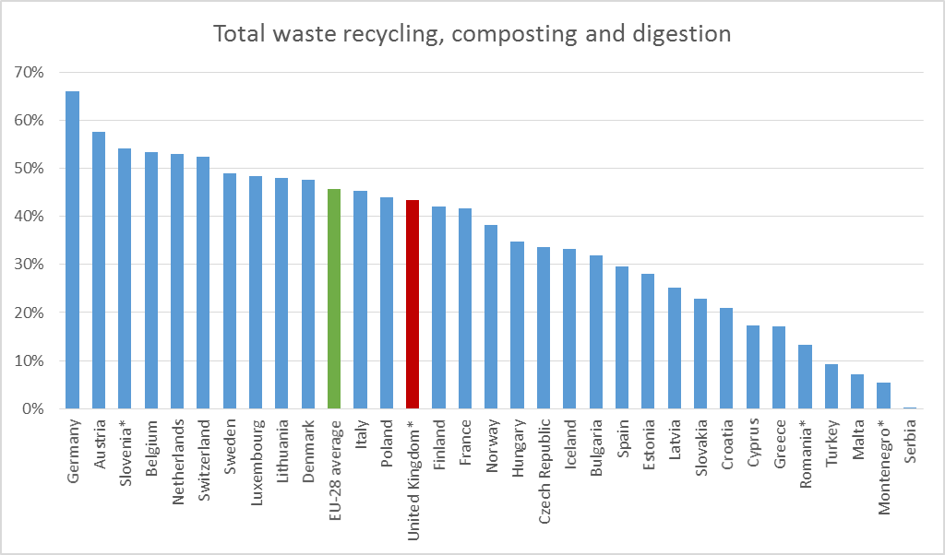
* latest data is for 2015
Endnotes

We Blues are the real Greens, The Conservative, 2 January 2017, link
Government's vision for a greener future launched, Department for Environment, Food & Rural Affairs, 11 January 2018, link
Farming for the next generation, DEFRA, 5 January 2018, link
A Green Future: Our 25 Year Plan to Improve the Environment, DEFRA, 11 January 2018, link
Environment charities welcome 25 Year Environment Plan, but an Environment Act needs to secure its success, Wildlife and Countryside Link, 11 January 2018, link
Climate Change Minister Claire Perry launches Powering Past Coal Alliance at COP23, Department for Business, Energy & Industrial Strategy, 16 November 2017, link
Government reaffirms commitment to lead the world in cost-effective clean growth, DBEIS, 12 October 2017, link
UK Blue Belt - global ambitions for marine protection, Marine Management Organisation, 5 September 2017, link
Clean Growth Strategy, DBEIS, 12 October 2017, link
Conservatism rejuvenated: appealing to the under 40s, Bright Blue, 30 September 2017: link
Green conservatives? Understanding what conservatives think about the environment, Bright Blue, 4 April 2017, link
Issues Index January 2018, Ipsos Mori, 8 February 2018, link
Prime Minister's speech on the environment, Prime Minister's Office, 11 January 2018, link
'Blue Belt' extended to protect 8,000 square miles of UK waters, DEFRA, 17 January 2016, link
World-leading microbeads ban takes effect, DEFRA, 9 January 2018, link
Environment Secretary pledges action on ocean plastics, DEFRA, 21 July 2017, link
New steps to tackle littering announced, DEFRA, 24 October 2017, link
Views sought on reward and return schemes for drinks containers, DEFRA, 2 October 2017, link
Plan for roadside NO2 concentrations published, DEFRA, 26 July 2017, link; see also Autumn Budget 2017: 25 things you need to know, HMT, 22 November 2017, link and Autumn Budget 2017: Philip Hammond's speech, HMT, 22 November 2017, link
PM announces new measures to tackle effects and causes of climate change, Prime Minister's Office, 12 December 2017, link
New environmental protections to deliver a Green Brexit, DEFRA, 12 November 2017, link
Government sets out plans for ivory ban, DEFRA, 6 October 2017, link
London Conference on the Illegal Wildlife Trade 2014, DEFRA, 13 February 2014, link
CCTV to be introduced in all slaughterhouses in England in 2018, DEFRA, 12 November 2017, link
Sentences for animal cruelty to increase tenfold to five years, DEFRA, 30 September 2017, link
Environment Secretary publishes bill to strengthen animal welfare, DEFRA, 12 December 2017, link
Environment Secretary opens £40 million fund to boost farm productivity, DEFRA, 30 October 2017, link
England's largest woodland planting scheme gets green light, DEFRA, 30 November 2017, link
£13 million fund to increase England's woodland, DEFRA, 20 July 2017, link
Environment Secretary backs release of Beavers in Forest of Dean, DEFRA, 8 December 2017, link
Environment Secretary backs further restrictions on neonicotinoid pesticides, DEFRA, 9 November 2017, link
Labour has treated the environment as an afterthought – that needs to change, The Guardian, 7 August 2015, link
Where Labour failed, Progress, 23 September 2010, link (via the Internet Archive)
Tony Blair EU rebate 'surrender' to cost billions more than estimated, The Telegraph, 4 December 2010, link
In the period 2008-2010, 26 per cent of all discards at sea were estimated to be due to fishermen exceeding their quota. 2010 to 2015 government policy: marine fisheries, Appendix 4: reducing discards, DEFRA, updated 8 May 2015, link
Public Forest Estate (England), Hansard, 2 February 2011, Vol 522, link; The Forestry Commission and the sale of public forests in England, House of Commons Library, SN/SC/5734, 28 November 2014, link
Planning for Gypsy and Traveller Caravan Sites, ODPM Circular 01/2006, Office of the Deputy Prime Minister, February 2006, link
In 2007, despite an increase in funding “the state of flood defences in England has not improved markedly… Some flood defences remain in a poor condition and over half of the high risk flood defence systems, such as those protecting urban areas, are not in their target condition.” Environment Agency: Building and maintaining river and coastal flood defences in England, Public Accounts Committee, 18 December 2007, link
Learning the Lessons from the 2007 floods, Pitt Review, June 2008, link
Dairy Farming, Hansard, 20 October 2008, Col.28W, link; Dairy Farming, Hansard, 9 September 2009, Col.1914W, link
Foot and Mouth Disease 2007: A Review and Lessons Learned, House of Commons, 11 March 2008, link; Foot and Mouth Disease, Hansard, 12 December 2007, Col. 708WA, link
Why officials in Labour government pushed 'dash for diesel', BBC News, 16 November 2017, link
Municipal waste by waste operations (env_wasmun), Eurostat, 22 January 2018, link
Plastic Bottle Deposit Plans Likely to be Ditched by UK Government, Waste Management World, 15 February 2017, link

